*CONDITIONAL FORMATTING IN POWER BI*

*DAX*

**Dashboard contains :**

* State
* Product Amount
* Quantity
* Color
* Font Color
* Product

**Measure Created:**

**Highest value:**

MaxProductAmount = MaxX(VALUES(Data[State]), CALCULATE(SUM(Data[Product Amount])))

**Average Value:**

Avgeragex ProductAmount = AverageX(VALUES(Data[State]), CALCULATE(SUM(Data[Product Amount])))

**Lowest Value:**

MinProductAmount = MINX(VALUES(Data[State]), CALCULATE(SUM(Data[Product Amount])))

**Column Created:**

FontColor =

SWITCH( TRUE(),

Sheet1[Color] = "Brown", "#A52A2A",

Sheet1[Color] = "Gray", "#808080",

Sheet1[Color] = "Orange", "#FFA500",

Sheet1[Color] = "Purple", "#800080",

Sheet1[Color] = "Violet", "#EE82EE",

Sheet1[Color] = "White", "#FFFFFF",

Sheet1[Color] = "Blue", "#0000FF",

Sheet1[Color] = "Cyan", "#00FFFF",

Sheet1[Color] = "Green", "#008000",

Sheet1[Color] = "Yellow", "#FFFF00",

Sheet1[Color] = "Black", "#000000",

Sheet1[Color] = "Red", "#FF0000",

Sheet1[Color] = "Magenta", "#FF00FF",

Sheet1[Color] = "Pink", "#FFC0CB",

Sheet1[Color] = "Indigo", "#4B0082”

)

**Conditional Formatting Created:**

IF,

SWITCH ,

AND,

OR,

NOT,

ERROR.

**STEP 1 :**

Inserting a Dataset to make a visualization.

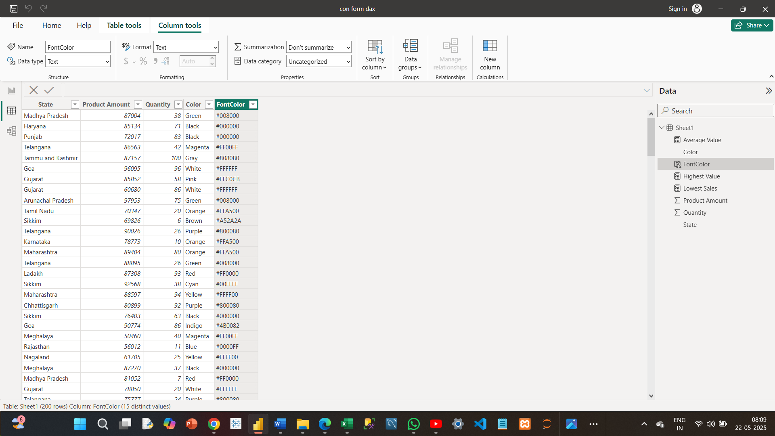

**STEP 2 :**

In this visualization , I have created the Background color values for the **highest value , average value , middle value , lowest value .**

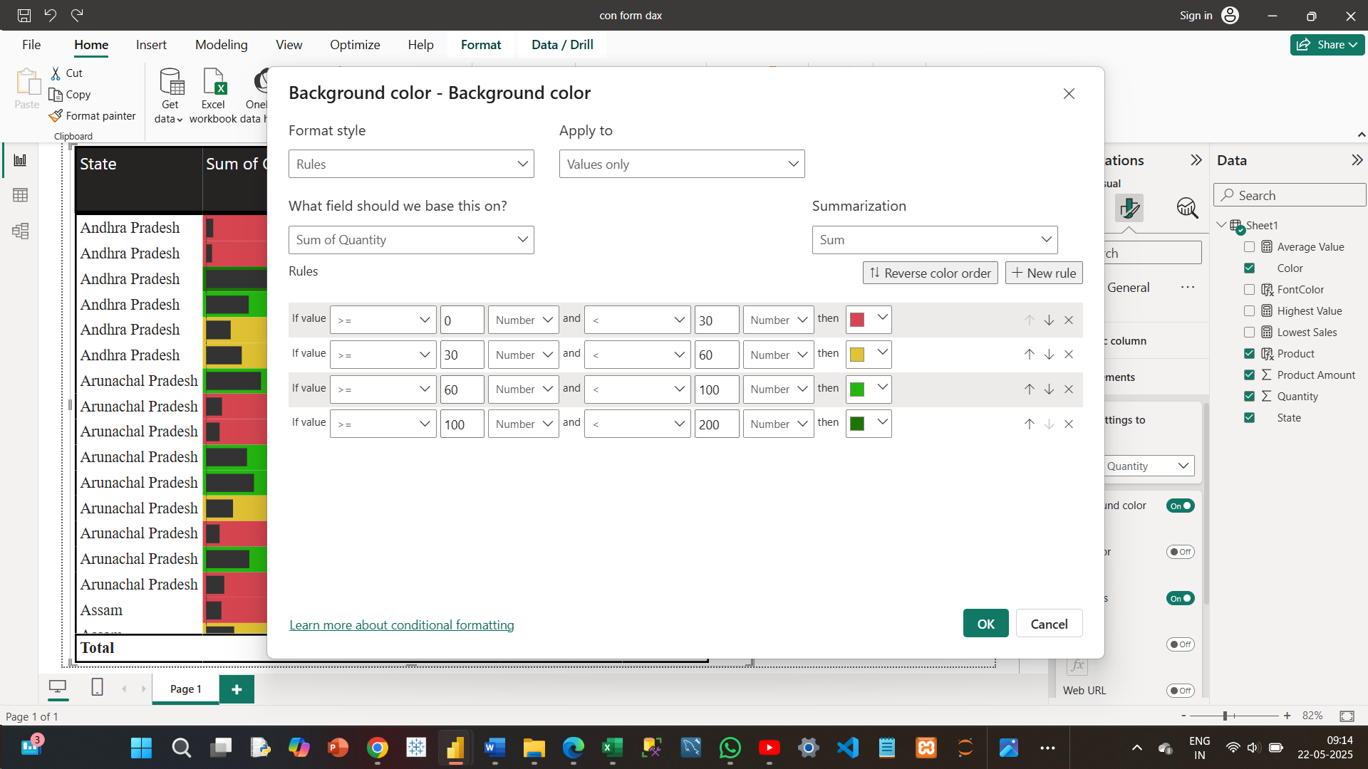

**After :**

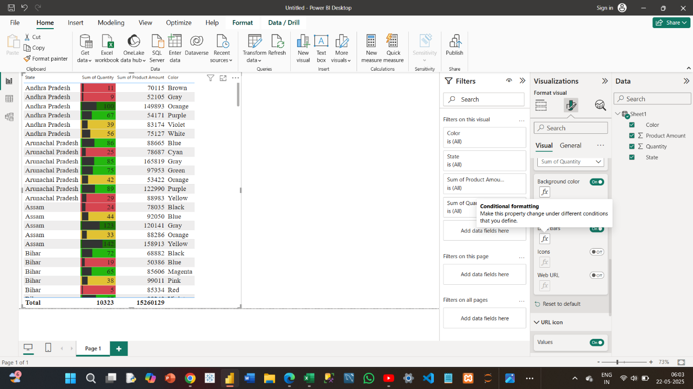

**STEP 3 :**

Calculation for the **Highest value** .Calculation for **Lowest Value ,** Calculation for **Average Value.**

**Highest value:**

MaxProductAmount = MaxX(VALUES(Data[State]), CALCULATE(SUM(Data[Product Amount])))

**Average Value:**

Avgeragex ProductAmount = AverageX(VALUES(Data[State]), CALCULATE(SUM(Data[Product Amount])))

**Lowest Value:**

MinProductAmount = MINX(VALUES(Data[State]), CALCULATE(SUM(Data[Product Amount])))

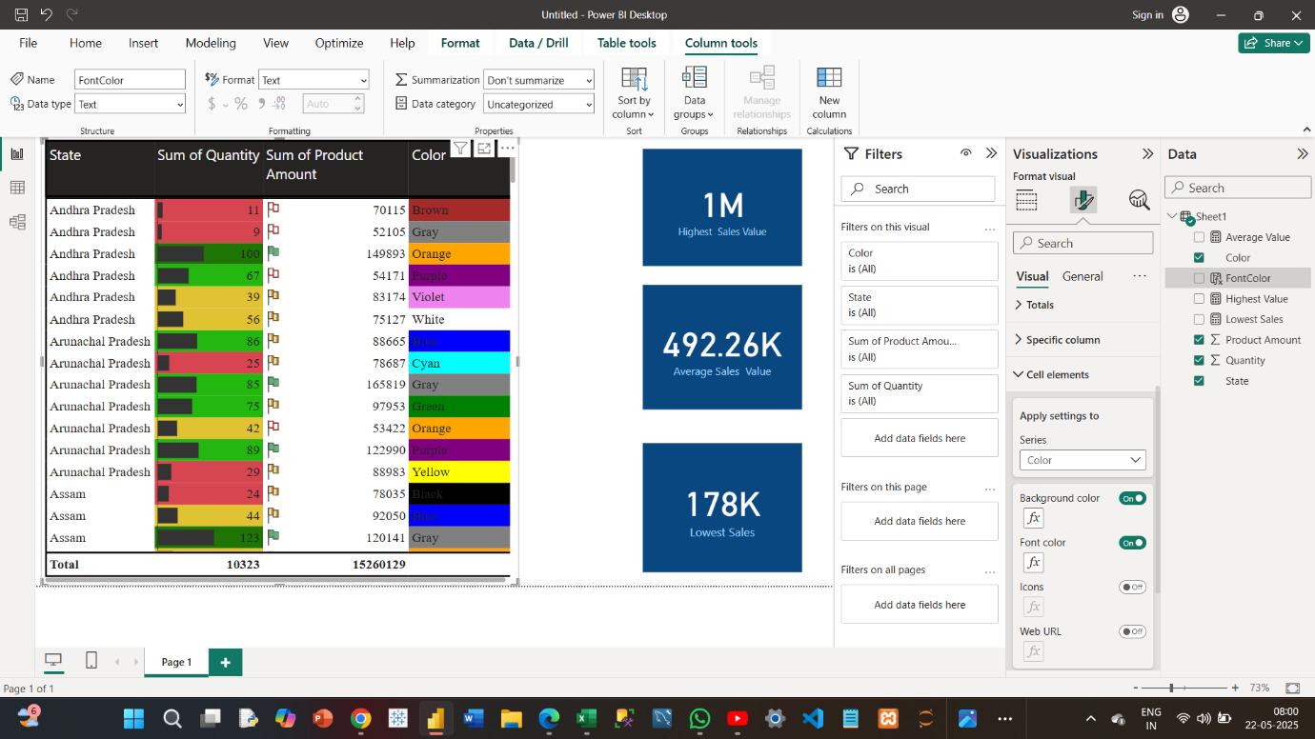**STEP 4 :**

This visualization iss for creating a background Color for the Particular color it self

Example : for the value “RED” it show the “RED” color background.

**Before:**

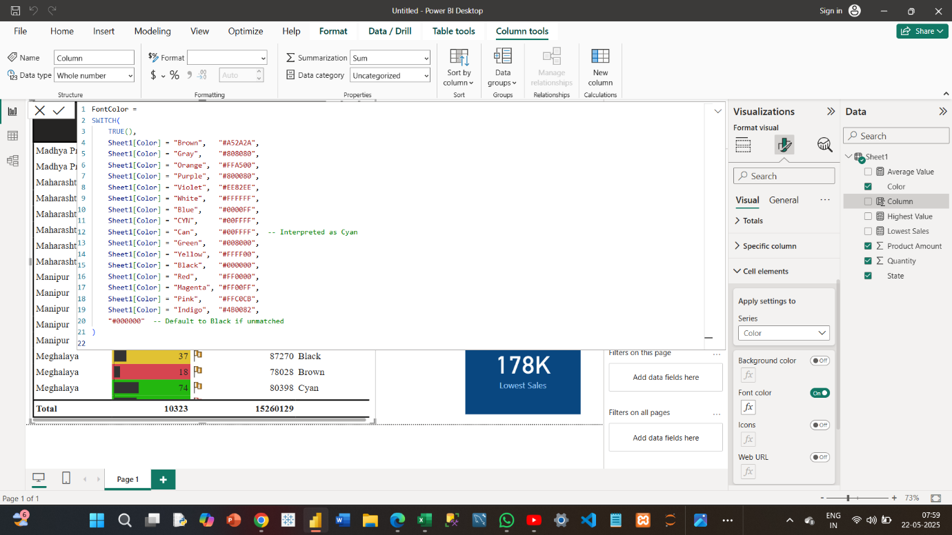

**After:**

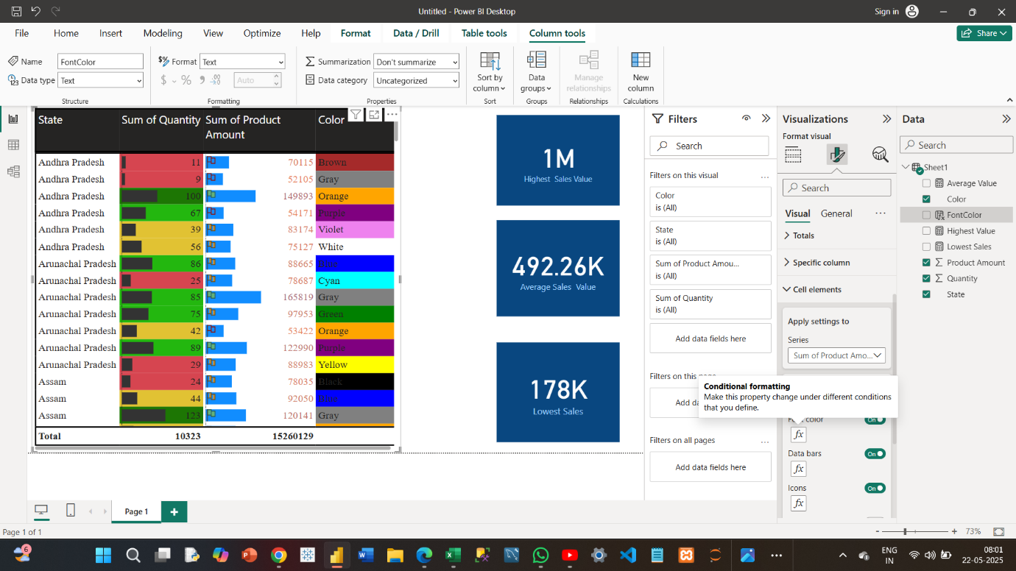

**STEP 5 :**

Making icons , based on the rules .

**Before:**



**After:**

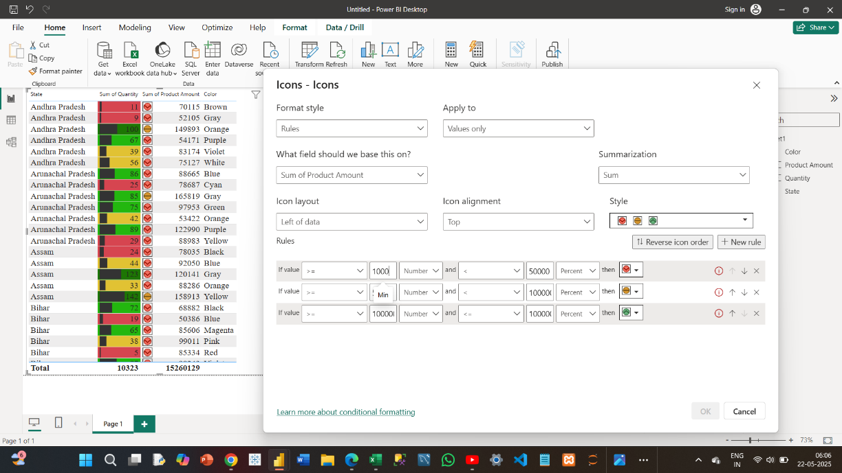

**STEP 6 :**

Final Dashboard

